Topic 4. Orthogonal contrasts [ST&D p. 183]

ANOVA is a useful and powerful tool to compare several treatment means. In comparing t treatments, the null hypothesis tested is that the t true means are all equal (H₀: µ₁ = µ₂ = ... = µ_{t}). If the F test is significant, one accepts the alternative hypothesis, which merely states that they are not all equal (i.e. at least one mean is different). Since the test does not tell you which mean(s) is/are different, the information provided by this initial F test is limited.
Further comparisons to determine which specific treatment means are different can be carried out by further partitioning the treatment sum of squares (SST) to provide additional F tests to answer planned questions. The orthogonal contrast approach to mean separation is described as planned F tests. These tests are planned in the sense that the questions of interest are decided upon before looking at the data. In fact, the questions of interest dictate the treatment structure from the very beginning of the experiment. With planned tests, therefore, there is a priori knowledge, based either on biological considerations or on the results of preliminary investigations, as to which comparisons are most important to make.
Said another way, if the investigator has specific questions to be answered, treatments are chosen (i.e. a treatment structure is designed) to provide information and statistical tests to answer those specific questions. An experienced investigator will select treatments so that the treatment sum of squares (SST) can be partitioned perfectly to answer as many independent (i.e. orthogonal) questions as there are degrees of freedom for treatments in the ANOVA. Consequently, another name of these tests is single degree of freedom tests.

4. 1. Definitions of contrast and orthogonality [ST&D p. 183]
"Contrast" is mathematical jargon for a linear combination of terms (a polynomial) whose coefficients sum to zero. In ANOVA, "contrast" assumes a more limited definition: A contrast (Q) is a linear combination of two or more factor level means whose coefficients sum to zero:
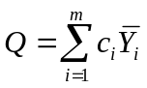, with the constraint that 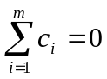

As an example, consider a comparison of two means, the simplest contrast:

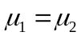

This is the same as 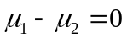, where 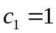, 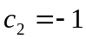, and 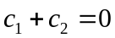

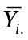It is essential that the sum of the coefficients for each comparison is zero. The terms are the treatment means (it can also be the treatment sums), and m ≤ t, is the number of treatments being compared. For convenience, the c_{i}‘s are usually integers. A contrast always has a single degree of freedom.

Orthogonal: Now consider two contrasts
Suppose 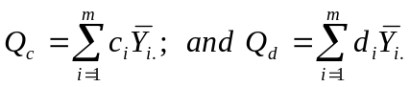.
These two contrasts are said to be orthogonal to one another if the sum of the products of any pair of corresponding coefficients is zero.
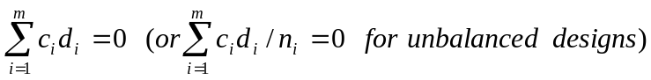
So, orthogonality is a property of a set of two contrasts. A set of more than two contrasts is said to be orthogonal only if each and every pair within the set exhibits pair-wise orthogonality, as defined above. To declare a set of four contrasts (Q₁ – Q₄) to be orthogonal, therefore, one must show that each of the six possible pairs are orthogonal: (Q₁ and Q₂, Q₁ and Q₃, Q₁ and Q₄, Q₂ and Q₃, Q₂ and Q₄, Q₃ and Q₄).

Why do we care? Remember in our discussion of CRDs that the total SS could be perfectly partitioned into two parts: The treatment SS and the error SS:

TSS = SST + SSE

This perfect partitioning is possible due to the fact that, mathematically, SST and SSE are orthogonal to one another. In an analogous way, orthogonal contrasts allow us to partition SST (i.e. decompose the relatively uninformative H₀ of the ANOVA) into a maximum of (t - 1) meaningful and targeted comparisons involving different combinations of means.

Suppose a set of (t – 1) contrasts is orthogonal. If the SS for each contrast are added together, their sum will exactly equal the SST for the original experiment. This means that an experiment can be partitioned into (t – 1) separate, independent experiments, one for each contrast.

Example
Suppose we are testing three treatments, T1, T2 and T3 (control) with treatment means μ1, μ2, and μ3 (two d.f.). The null hypothesis for the ANOVA is H₀: μ₁ = μ₂ = μ₃ which uses both degrees of freedom in one test (df_{t}= t-1 = 2). Since there are two degrees of freedom for treatments, there are in principle two independent comparisons that can be made.
For example, one could in principle test the two hypotheses that μ₁ and μ₂ are not significantly different from the control: μ₁ = μ₃ and μ₂ = μ₃. As usual, we represent the means μ_{i} with their estimates 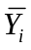
1.- μ₁ = μ₃ can be rewritten as 1μ₁ + 0μ₂ -1μ₃= 0
the coefficients of this contrast are: c1 = 1, c2 = 0, c3 = -1

2.- μ₂ = μ₃ can be rewritten as 0μ₁ + 1μ₂ -1μ₃= 0
the coefficients of this contrast are: d1 = 0, d2 = 1, d3= -1

These linear combinations of means are contrast because
(1 + 0 + (-1) = 0); and 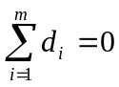 (0 + 1 + (-1) = 0).
However these contrasts are not orthogonal because:
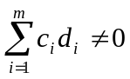 (c1d1 + c2d2+ c3d3 = 0 + 0 + 1 = 1).
So, not every pair of hypotheses can be tested using this approach. In addition to summing to 0, the c_{i} coefficients are almost always taken to be integers, a constraint which severely restricts their possible values.
For t = 3 such a set of values are
1) c1 = 1, c2 = 1, c3 = -2;
2) d1 = 1, d2 = -1, d3 = 0.
These are contrasts since
(1 + 1 + (-2) = 0 and 1+ (-1) + 0= 0)
and are orthogonal because
(c1d1 + c2d2+ c3d3 = 1 + (-1) + 0 = 0).

Just as not all sets of hypotheses can be asked using orthogonal contrasts, not all sets of orthogonal contrasts correspond to meaningful (or interesting) hypotheses. In this example, the contrasts are, in fact, interesting. The hypotheses they define are:

1) The average of the two treatments is equal to the control (i.e. is there a significant average treatment effect?); and
2) The two treatments are equal to one another (i.e. is one treatment significantly different from the other?).

There are two general kinds of linear combinations:
- Class comparisons
- Trend comparisons.
4. 2. Class comparisons
The first category of hypothesis we can pose using orthogonal contrasts is class (or group) comparisons. Such contrasts compare specific treatment means or combinations of treatment means, grouped is some meaningful way. The procedure is illustrated by an example on page 185 of ST&D, which involves the mint data discussed in Topic 3.
To illustrate orthogonal contrasts in class comparisons we will use the data given in Table 4.1. The analysis of variance for this experiment is given in Tables 4.2.

Table 4.1. Results (mg shoot dry weight) of an experiment (CRD) to determine the effect of seed treatment by ≠ acids on the early growth of rice seedlings.

 |  |  |  |  |  | Total | Mean
Treatment | Replications |  |  |  |  | 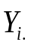 | 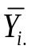
Control | 4.23 | 4.38 | 4.1o | 3.99 | 4.25 | 20.95 | 4.19
HC1 | 3.85 | 3.78 | 3.91 | 3.94 | 3.86 | 19.34 | 3.87
Propionic | 3.75 | 3.65 | 3.82 | 3.69 | 3.73 | 18.64 | 3.73
Butyric | 3.66 | 3.67 | 3.62 | 3.54 | 3.71 | 18.20 | 3.64
Overall |  |  |  |  | 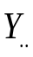 = 77.13 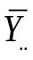 = 3.86

Table 4.2. ANOVA of data in Table 4.1 (t = 4, r = 5)
Source of  Variation | df | Sum of  Squares | Mean  Squares | F
Total | 19 | 1.0113
Treatment | 3 | 0.8738 | 0.2912 | 33.87
Error | 16 | 0.1376 | 0.0086

The treatment structure of this experiment suggests that the investigator had several specific questions in mind from the beginning:
1) Do acid treatments affect seedling growth?
2) Is the effect of =organic acids different from that of inorganic acids?
3) Is there a difference in the effects of the two different organic acids?
These are planned questions and so are appropriate candidates for posing via orthogonal contrasts. To do this, we must restate these questions mathematically, as linear combinations of treatments. In the following table (Table 4.3), coefficients are shown that translate these three planned questions into contrasts.

Table 4.3. Orthogonal coefficients for partitioning the SST of Table 4.2. into 3 independent tests.
 |  | Control | HC1 | Propionic | Butyric
Control vs. acid |  | +3 | -1 | -1 | -1
Inorganic vs. organic |  | 0 | -2 | +1 | +1
Between organics |  | 0 | 0 | +1 | -1
 | Totals | 20.95 | 19.34 | 18.64 | 18.2
Comparisons | Means | 4.19 | 3.87 | 3.73 | 3.64

The 1st contrast (first row) compares the control group to the average of the three acid-treated groups, as can be seen from the following manipulations:

- 3μ_{Cont} - 1μ_{HCl} - 1μ_{Prop} - 1μ_{But} = 0
- μ_{Cont} = (1/3)*(1μ_{HCl} + 1μ_{Prop} + 1μ_{But})
- Mean of the control group = Mean of all acid-treated groups

The H₀ for this 1st contrast is that there is no average effect of acid treatment on seedling growth. Since this H_{o} involves only two group means, it costs 1 df.

The 2nd contrast (second row) compares the inorganic acid group to the average of the two organic acid groups:

- 0μ_{Cont} + 2μ_{HCl} - 1μ_{Prop} - 1μ_{But} = 0
- μ_{HCl} = (1/2)*(1μ_{Prop} + 1μ_{But})
- Mean of the HCl group = Mean of all organic acid-treated groups

The H₀ for this second contrast is that the effect of the inorganic acid treatment on seedling growth is no different from the average effect of organic acid treatment. Since this null hypothesis involves only two group means (≠means than before), it also costs 1 df.

Finally, the third contrast (third row of coefficients) compares the two organic acid groups to each other:

- 0μ_{Cont} + 0μ_{HCl} + 1μ_{Prop} - 1μ_{But} = 0
- 1μ_{Prop} = 1μ_{But}
The H₀ for this third contrast is that the effect of the propionic acid treatment on seedling growth is no different from the effect of butyric acid treatment. Since this null hypothesis involves only two group means (different means than before), it also costs 1 df. At this point, we have spent all our available degrees of freedom (df_{trt} = t – 1 = 4 – 1 = 3).
Because each of these questions are contrasts (each row of coefficients sums to zero) and because the set of three questions is orthogonal (verify this for yourself), these three question perfectly partition SST into three components, each with 1 df. The SS associated with each of these contrasts serve as the numerators for three separate F tests, one for each comparison. The critical F values for these single df tests are based on 1 df in the numerator and df_{Error} in the denominator. All of this can be seen in the expanded ANOVA table below.
Table 4.4 Orthogonal partitioning of SST via contrasts.
Source | df | SS | MS | F
Total | 19 | 1.0113
Treatment | 3 | 0.8738 | 0.2912 | 33.87
1. Control vs. acid | 1 | 0.7415 | 0.7415 | 86.22
2. Inorg. vs. Org. | 1 | 0.1129 | 0.1129 | 13.13
3. Between Org. | 1 | 0.0194 | 0.0194 | 2.26
Error | 16 | 0.1376 | 0.0086

Notice that SST = SS_{Contrast1} + SS_{Contrast2} + SS_{Contrast3}. This perfect partitioning of SST among its degrees of freedom is a direct consequence of the orthogonality of the posed contrasts. When comparisons are not orthogonal, the SS for one comparison may contain (or be contained by) part of the SS of another comparison. Therefore, the conclusion from one test may be influenced (or contaminated) by another test and the SS of those individual comparisons will not sum to SST.

Computation: The computation of the sum of squares for a single degree of freedom F test for linear combinations of treatment means is

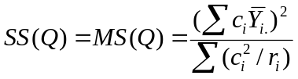
This expression simplifies to 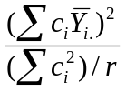 in balanced designs (all r's equal)

- SS₁ (control vs. acid) = [3(4.19) – 3.64 – 3.73 – 3.87]² / [(12)/5] = 0.74
- SS₂ (inorg. vs. org.) = [3.64 + 3.73 – 2(3.87)]² / [(6)/5] = 0.11
- SS₃ (between org.) = [-3.64 + 3.73]² / [(2)/5] = 0.02
Note: ST&D formulas for contrasts (p. 184) are for treatment totals instead of treatment means. The treatments means formula is required for unbalanced designs.

From this analysis, we conclude that in this experiment acids significantly reduce seedling growth (F = 86.22, p < 0.01), that the organic acids cause significantly more reduction than the inorganic acid (F = 13.13, p < 0.01), and that the difference between the organic acids is not significant (F = 2.26, p > 0.05).

Construction of coefficients for class comparisons (Little & Hills p 66).
Contrast coefficients for a class comparison can always be determined by writing the null hypothesis in mathematical form, moving all terms to the same side of the equation, and multiplying by whatever factor is needed to turn the coefficients into integers. This is a general strategy. What follows are more recipe-like, step-by-step operations to arrive at the same results:
- When the two groups of means being compared each contain the same number of treatments assign +1 to the members of one group and -1 to the members of the other. Thus for line 3 in Table 4.3, we are comparing two means, and assign coefficients of 1 (of opposite sign) to each. The same procedure extends to the case of more than one treatment per group.
- When comparing groups containing different numbers of treatments, assign to the first group coefficients equal to the number of treatments in the second group; to the second group, assign coefficients of opposite sign, equal to the number of treatments in the first group. Thus, if among 5 treatments, the first two are to be compared to the last three, the coefficients would be +3, +3, -2, -2, -2. In Table 4.3, where the control mean is compared with the mean of the three acids, we assign a 3 to the control and a 1 to each of the three acids. Opposite signs are then assigned to the two groups. It is immaterial as to which group gets the positive or negative sign since it is the sum of squares of the comparison that is used in the F-test.
- The coefficients for any comparison should be reduced to the smallest possible integers for each calculation. Thus, +4, +4, -2, -2, -2, -2, should be reduced to +2, +2, -1, -1, -1, -1.
- The coefficients for an interaction comparison are determined by simply multiplying the corresponding coefficients of the two underlying main comparisons. See next example (Table 4.5).
Example: Fertilizer experiment designed as a CRD with four treatments. The four treatments result from all possible combinations of two levels of both nitrogen (N₀ = 0 N, N₁ = 100 lbs N/ac) and phosphorus (P₀ = 0 P, P₁ = 20 lbs P/ac).

The questions intended by this treatment structure are:
1. Is there an effect of N on yield?
2. Is there an effect of P on yield?
3. Is there an interaction between N and P on yield?

Equivalent ways of stating the interaction question:
a) Is the effect of N the same in the presence of P as it is in the absence of P? b) Is the effect of P the same in the presence of N as it is in the absence of N?)

The following table (Table 4.5) presents the contrast coefficients for these planned questions.

Table 4.5. Fertilizer experiment with 4 treatments, 2 levels of N and 2 of P.
 | N₀P₀ | N₀P₁ | N₁P₀ | N₁P₁
Between N | -1 | -1 | 1 | 1
Between P | -1 | 1 | -1 | 1
Interaction (NxP) | 1 | -1 | -1 | 1
The coefficients for the 1st two comparisons are derived by rule 1. The interaction coefficients are the result of multiplying the coefficients of the first two lines.

Note that the sum of the coefficients of each comparison is 0 and that the sum of the cross products of any two comparisons is also 0. When these 2 conditions are met, the comparisons are said to be orthogonal. This implies that the conclusion drawn for one comparison is independent of (not influenced by) the others.

4. 3. Trend comparisons

Experiments are often designed to characterize the effect of increasing levels of a factor (e.g. increments of a fertilizer, planting dates, doses of a chemical, concentrations of a feed additive, etc.) on some response variable (e.g. yield, disease severity, growth, etc.). In these situations, the experimenter is interested in the dose response relationship. Such an analysis is concerned with overall trends and not with pairwise comparisons.
The simplest example involves a single factor with three levels. This is very common situation in genetic experiments, where the levels are:
- 0 dose of allele A in homozygous BB individuals
- 1 dose of allele A in heterozygous AB individuals
- 2 doses of allele A in homozygous AA individuals.
With the use of molecular markers it is now easy to score the genotype of the individuals of a segregating population and classify them into one of these three groups (AA, AB, BB). These individuals are also phenotyped for the trait of interest. Suppose 40 segregating F₂ individuals genotyped for a certain molecular known to be linked to a gene affecting N translocation to the grain. The Nitrogen content of the seed is measured in the same 40 individuals.
Table 4.6. Genetic example of orthogonal contrasts. Nitrogen content (mg) of seeds of three different genotypes.

Genotype (BB) | Genotype (AB) | Genotype (AA)
0 doses, A allele | 1 dose, A allele | 2 doses, A allele
12.0 | 13.5 | 13.8
12.5 | 13.8 | 14.5
12.1 | 13.0 | 13.9
11.8 | 13.2 | 14.2
12.6 | 13.0 | 14.1
 | 12.8
 | 12.9
 | 13.4
 | 12.7
 | 13.6

Unequal replication is common in genetic experiment due to segregation ratios. In F₂ populations, the expected ratio of homozygous to heterozygous individuals is 1:2:1, which is what we see in the dataset above. Each individual is an independent replication of its respective genotype; so there are five replications of genotype BB, ten replications of genotype AB, and five replications of genotype AA in this experiment. The "treatment" is dosage of the A allele, and the response variable is seed nitrogen content.
With three levels of dosage, the most complicated response the data can reveal is a quadratic relationship between dosage (D) and N content:
N = aD² + bD + c
This quadratic relationship is comprised of two components: A linear component (slope b), and a quadratic component (curvature a). It just so happens that, with 2 treatment degrees of freedom (df_{trt} = t – 1 = 3 – 1 = 2), we can construct orthogonal contrasts to probe each of these components.
To test the hypothesis that b = 0 (i.e. there is 0 slope in the overall dosage response relationship), we choose H₀: μ_{BB} = μ_{AA}. If the means of the two extreme dosages are equal, b = 0. As a contrast, this H₀ takes the form: 1μ_{BB} + 0μ_{AB} - 1μ_{AA} = 0.
To test the hypothesis that a = 0 (i.e. there is zero curvature in the overall dosage response relationship), we choose H₀: μ_{AB} = (1/2)*(μ_{AA} + μ_{BB}). Because the dosage levels are equally spaced (0, 1, 2), a perfectly linear relationship (i.e. zero curvature) would require that the average of the extreme dosage levels [(1/2)*(μ_{AA} + μ_{BB})] exactly equal the mean of the heterozygous group (μ_{AB}). As a contrast, this H₀ takes the form: 1μ_{BB} - 2μ_{AB} + 1μ_{AA} = 0.
A quick inspection shows each of these polynomials to be contrasts (i.e. their coefficients sum to zero) as well as orthogonal to each other (1*1 + 0*(-2) + (-1)*1 = 0).
Constructing F tests for these contrasts follows the exact same procedure we saw above in the case of class comparisons. So this time, let's use SAS:

SAS program:

Data GeneDose;
Input Genotype $ N;
Cards;
BB 12.0
BB 12.5
BB 12.1
BB 11.8
BB 12.6
AB 13.5
AB 13.8
AB 13.0
AB 13.2
AB 13.0
AB 12.8
AB 12.9
AB 13.4
AB 12.7
AB 13.6
AA 13.8
AA 14.5
AA 13.9
AA 14.2
AA 14.1
;
Proc GLM Order = Data;
Class Genotype;
Model N = Genotype;
Contrast 'Linear' Genotype 1 0 -1;
Contrast 'Quadratic' Genotype 1 -2 1;
Run;
Quit;

The resultant ANOVA table:
Source | df | SS | MS | F | p
Total | 19 | 11.022
Model | 2 | 9.033 | 4.5165 | 38.60 | < 0.0001
Error | 17 | 1.989 | 0.117
R-Square: | 0.819543
Contrast | df | SS | MS | F | p
Linear | 1 | 9.025 | 9.025 | 77.14 | < 0.0001
Quadratic | 1 | 0.008 | 0.008 | 0.07 | 0.7969

The fact that the contrast SS sum perfectly to the SST is a verification of their orthogonality. The significant linear contrast (p < 0.0001) leads us to the reject its H₀. There does appear to be a significant, nonzero linear component to the response. The non-significant quadratic contrast (p = 0.7969), however, leads us not to reject its H₀. Since the quadratic contrast is not significant we do not reject the hypothesis of a linear response. From the boxplot graph, there does not appear to be a quadratic component to the response (the middle mean is aligned with the line between the extreme means):

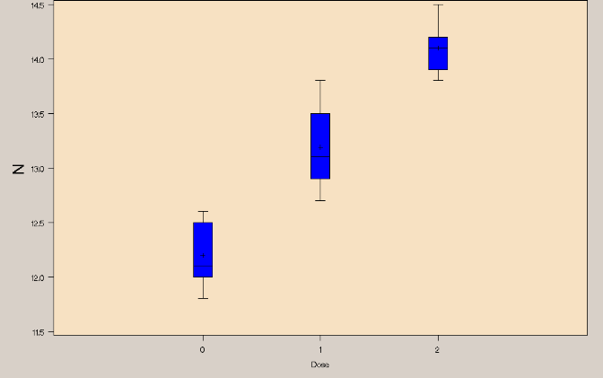
μ₁ - μ₂ ≠ 0

We would conclude from all this that the dosage response of nitrogen seed content to the presence of allele A is linear.
Before we move on, notice that when there is no significant quadratic response, the F value of the linear response (77.14, critical value F_{2,17} = 3.59) is twice as large as the Model F value (38.50, critical value F_{1,17} = 4.45). The reason for this: In the linear contrast, MS = SS/1, while in the complete Model, MS = SS/2 (i.e. the full SST is divided in half and arbitrarily assigned equally to both effects). When a quantitative factor exhibiting a significant linear dose response is measured at several levels, it is possible to have a non-significant overall treatment F test but a significant linear response. This is because the overall treatment F test divides the full SST equally across many effects, most of which are non-significant. This obscures the significance of the true linear effect. In such cases, contrasts significantly increase the power of the test.

Here is a similar dataset, but now the response variable is days to flowering (DTF).

Table 4.7 Days to flowering (DTF) of seeds of three different genotypes.
Genotype (BB) | Genotype (AB) | Genotype (AA)
0 doses, A allele | 1 dose, A allele | 2 doses, A allele
58 | 71 | 73
51 | 75 | 68
57 | 69 | 70
59 | 72 | 71
60 | 68 | 67
 | 73
 | 69
 | 70
 | 71
 | 72

The SAS coding is identical in this case.

The resultant ANOVA table:

Source | df | SS | MS | F | p
Total | 19 | 811.20
Model | 2 | 698.40 | 349.200 | 52.63 | < 0.0001
Error | 17 | 112.80 | 6.635
R-Square: | 0.860947
Contrast | df | SS | MS | F | p
Linear | 1 | 409.6 | 409.6 | 61.73 | < 0.0001
Quadratic | 1 | 288.8 | 288.8 | 43.52 | < 0.0001

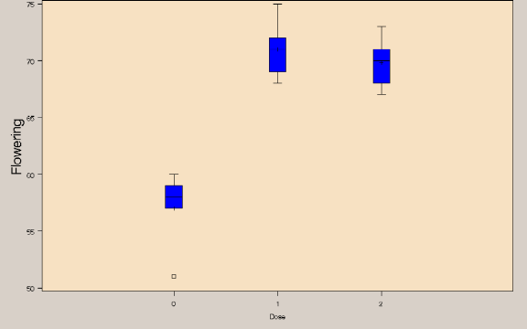
Again, the contrast SS sum perfectly to the SST, a verification of their orthogonality. The significant linear contrast (p < 0.0001) leads us to the reject its H₀. There does appear to be a significant, nonzero linear component to the response. And the significant quadratic contrast (p < 0.0001), leads us to reject its H₀ as well. There does appear to be a significant, nonzero quadratic component to the response.

All this can be seen quite easily
μ₂ - (1/2)*(μ₁ + μ₃) ≠ 0

in the following combined boxplot:

We would conclude from all this that the dosage response of flowering to the presence of allele A has both a linear and a quadratic component. In genetic terms, there is dominance.

If we were to analyze this last example via a simple lineal regression, we would obtain the following results:

Source | df | SS | MS | F | p
Total | 19 | 811.20
Model | 1 | 409.60 | 409.6 | 18.36 | 0.0004
Error | 18 | 401.60 | 22.3
401.6 = 112.8 + 288.8

The F value is smaller (18.36 < 61.73) because the quadratic SS (288.8) is now included in the error sum of squares (401.6 = 112.8 + 288.8). The message: An ANOVA with linear and quadratic contrasts is more sensitive to linear effects than a linear regression test. A quadratic regression test, however, will yield identical results to our analysis using contrasts.

Coefficients for trend comparisons
The c_{i} coefficients used for trend comparisons (linear, quadratic, cubic, quartic, etc.) among equally spaced treatments are listed below, taken from Table 15.12 (ST&D 390).
Contrast coefficients for trend comparisons for equally spaced treatments
No. of Treat. | Response | c1 | c2 | c3 | c4 | c5 | c6
2 | Linear | -1 | 1
3 | Linear | -1 | 0 | 1
3 | Quadratic | 1 | -2 | 1
4 | Linear | -3 | -1 | 1 | 3
4 | Quadratic | 1 | -1 | -1 | 1
4 | Cubic | -1 | 3 | -3 | 1
5 | Linear | -2 | -1 | 0 | 1 | 2
5 | Quadratic | 2 | -1 | -2 | -1 | 2
5 | Cubic | -1 | 2 | 0 | -2 | 1
5 | Quartic | 1 | -4 | 6 | -4 | 1
6 | Linear | -5 | -3 | -1 | 1 | 3 | 5
6 | Quadratic | 5 | -1 | -4 | -4 | -1 | 5
6 | Cubic | -5 | 7 | 4 | -4 | -7 | 5
6 | Quartic | 1 | -3 | 2 | 2 | -3 | 1
6 | Quintic | -1 | 5 | -10 | 10 | -5 | 1
As argued in the two previous examples, the values of these coefficients ultimately can be traced back to simple geometric arguments. The plot below shows the values of the linear and quadratic coefficients for t = 5:

X
X
X
T1
T5
+2
-2
X
X
X
X
X
X
X
X
To illustrate the procedure for evaluating a trend response when more treatment levels are involved, we will use the data from Table 15.11 (ST&D 387). To simplify matters, we will treat the blocks simply as replications in a CRD.

Table 4. 8. Partitioning SST using orthogonal polynomials. Yield of Ottawa Mandarin soybeans grown in MN (bushels / acre). [ST&D 387]

Rep.* | Row spacing (in inches)
 | 18 | 24 | 30 | 36 | 42
1 | 33.6 | 31.1 | 33 | 28.4 | 31.4
2 | 37.1 | 34.5 | 29.5 | 29.9 | 28.3
3 | 34.1 | 30.5 | 29.2 | 31.6 | 28.9
4 | 34.6 | 32.7 | 30.7 | 32.3 | 28.6
5 | 35.4 | 30.7 | 30.7 | 28.1 | 29.6
6 | 36.1 | 30.3 | 27.9 | 26.9 | 33.4
Means | 31.15 | 31.63 | 30.17 | 29.53 | 30.03
* Blocks treated as replications in this example

First of all, note that the treatment levels are equally spaced (18, 24, 30, 36, 42 → 6 inches between adjacent levels). Trend analysis via contrasts is greatly simplified when treatment levels are equally spaced (either arithmetic or log scales).

The contrast coefficients and the analysis:
 | Row spacing |  |  |  |  | 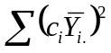 | 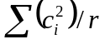 | SS | F
 | 18 | 24 | 30 | 36 | 42
Means | 35.15 | 31.63 | 30.17 | 29.53 | 30.03
Linear | -2 | -1 | 0 | 1 | 2 | 152.11 | 1.67 | 91.27 | 28.8***
Quadratic | 2 | -1 | -2 | -1 | 2 | 78.62 | 2.33 | 33.69 | 10.6**
Cubic | -1 | 2 | 0 | -2 | 1 | 0.84 | 1.67 | 0.50 | 0.16 NS
Quartic | 1 | -4 | 6 | -4 | 1 | 2.30 | 11.67 | 0.20 | 0.06 NS
In this trend analysis, we perfectly partitioned SST (125.66) among the four degrees of freedom for treatment, each degree of freedom corresponding to an independent, orthogonal contrast (linear, quadratic, cubic, and quartic components to the overall response). We conclude from this analysis that the relationship between row spacing and yield has significant linear and significant quadratic components. The cubic and quartic components are not significant. This can be seen easily in a scatterplot of the data:

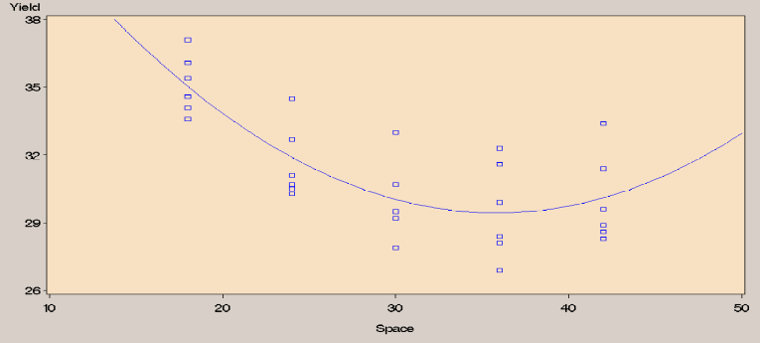

Unequally spaced treatments
There are equations to calculate coefficient similar to those of Table 15.12 for unequally spaced treatment levels and unequal numbers of replications. The ability to compute such sums of squares using orthogonal contrasts was crucial in the days before computers. But now it is easier to implement a regression approach, which does not require equal spacing between treatment levels [ST&D 388]. The SAS code for a full regression analysis of the soybean yield data:

Data Rows;
Do Rep = 1 to 6;
Do Sp = 18,24,30,36,42;
Input Yield @@;
Output;
End;
End;
Cards;
33.6 31.1 33 28.4 31.4
37.1 34.5 29.5 29.9 28.3
34.1 30.5 29.2 31.6 28.9
34.6 32.7 30.7 32.3 28.6
35.4 30.7 30.7 28.1 29.6
36.1 30.3 27.9 26.9 33.4
;
Proc GLM Order = Data;
Model Yield = Sp Sp*Sp Sp*Sp*Sp Sp*Sp*Sp*Sp;
Run;
Quit;

Note the absence of a Class statement! In regression, we are not interested in the individual levels of the explanatory variable; we are interested in the nature of overall trend. The output:

Sum of
Source DF Squares Mean Square F Value Pr > F
Model 4 125.6613333 31.4153333 9.90 <.0001
Error 25 79.3283333 3.1731333
Corrected Total 29 204.9896667

R-Square Coeff Var Root MSE Yield Mean
0.613013 5.690541 1.781329 31.30333

Source DF Type I SS Mean Square F Value Pr > F
Sp 1 91.26666667 91.26666667 28.76 <.0001 ***
Sp*Sp 1 33.69333333 33.69333333 10.62 0.0032 **
Sp*Sp*Sp 1 0.50416667 0.50416667 0.16 0.6936 NS
Sp*Sp*Sp*Sp 1 0.19716667 0.19716667 0.06 0.8052 NS

This is the exact result we obtained using contrasts (see code and output below):

Data Rows;
Do Rep = 1 to 6;
Do Sp = 18,24,30,36,42;
Input Yield @@;
Output;
End;
End;
Cards;
33.6 31.1 33 28.4 31.4
37.1 34.5 29.5 29.9 28.3
34.1 30.5 29.2 31.6 28.9
34.6 32.7 30.7 32.3 28.6
35.4 30.7 30.7 28.1 29.6
36.1 30.3 27.9 26.9 33.4
;
Proc GLM Order = Data;
Class Sp;
Model Yield = Sp;
Contrast 'Linear' Sp -2 -1 0 1 2;
Contrast 'Quadratic' Sp 2 -1 -2 -1 2;
Contrast 'Cubic' Sp -1 2 0 -2 1;
Contrast 'Quartic' Sp 1 -4 6 -4 1;
Run; Quit;

Sum of
Source DF Squares Mean Square F Value Pr > F
Model 4 125.6613333 31.4153333 9.90 <.0001
Error 25 79.3283333 3.1731333
Corrected Total 29 204.9896667

R-Square Coeff Var Root MSE Yield Mean
0.613013 5.690541 1.781329 31.30333

Source DF Type III SS Mean Square F Value Pr > F
Sp 4 125.6613333 31.4153333 9.90 <.0001

Contrast DF Contrast SS Mean Square F Value Pr > F
Linear 1 91.26666667 91.26666667 28.76 <.0001 ***
Quadratic 1 33.69333333 33.69333333 10.62 0.0032 **
Cubic 1 0.50416667 0.50416667 0.16 0.6936 NS
Quartic 1 0.19716667 0.19716667 0.06 0.8052 NS

So, as long as the treatment levels are equally spaced, the results are the same for both analyses. The multiple regression analysis can be used with unequally spaced treatments, but the orthogonal contrast analysis, with the provided coefficients, cannot.
Some remarks on treatment levels for trend analysis
The selection of dose levels for a material depends on the objectives of the experiment. If it is known that a certain response is linear over a given dose range and one is only interested in the rate of change, two doses will suffice, one low and one high. However, with only two doses there is no information available to verify the initial assumption of linearity. It is good practice to use one extra level so that deviation from linearity can be estimated and tested. Similarly, if a quadratic response is expected, a minimum of four dose levels are required to test whether or not a quadratic model is appropriate.
The variability in agricultural data is generally greater than for physical and chemical laboratory studies, as the experimental units are subject to less controllable environmental influences. These variations cause difficulty in analyzing and interpreting combined experiments that are conducted over different years or across different locations. Furthermore, true response models are rarely known. For these reasons, agricultural experiments usually require four to six levels to characterize a dose-response curve.

Final comment about orthogonal contrasts:

Powerful as they are, contrasts are not always appropriate.

If you have to choose, meaningful hypotheses
are more desirable than orthogonal ones!

